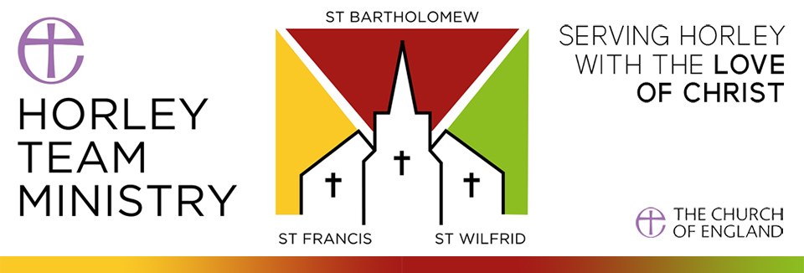

Oak Shingle Donation Form for St Bartholomew’s Church

We are starting work on repairing the spire and roof of this ancient building. The cost of replacing each oak shingle is £25. We are offering you the opportunity to support us by donating at least £10 towards purchasing an oak shingle in memory/celebration/ commemoration of a person or special event and having this recorded in a book, which will be kept in the church.

SURNAME .................................................................... FIRST NAME ................................................ TITLE .............

EMAIL ADDRESS ................................................................................. PHONE NUMBER………..................................

POSTAL ADDRESS ........................................................................................................................................................

.................................................................................................................................POSTCODE......................................

Please write/type your message in the box below. Should you wish to donate towards more than one shingle, please enter other information overleaf. Do you want your name mentioned in the book? Yes/No (please circle).
Eg: In memory of/to commemorate/to celebrate (life or occasion). Maximum 30 words.

Payment Method: Bank Transfer*/Cash/Cheque** (please indicate).

Donation Amount (min £10) ………………. I wish to Gift Aid my donation (please tick if the below applies)

I am a UK taxpayer and I would like PCC Horley Team Ministry to treat this donation and any donations I make in the future and have made in the past 4 years as Gift Aid donations, until I notify you otherwise.

I understand that if I pay less Income Tax and / or Capital Gains Tax than the amount of Gift Aid claimed on all my donations in that tax year it is my responsibility to pay any difference. I understand that PCC Horley Team Ministry will reclaim 25p of tax on every £1 that I give.

Signed:............................................................................... Date......................................................

*Name of a/c - PCC of St Bartholomew’s Horley Spire Fund
Lloyd’s Bank : Sort code- 30-94-38 A/C - 32027868 with your name and “Shingle” as the reference

** If paying by cheque, please make cheques payable to – PCC of St Bartholomew’s Horley Spire Fund with “Shingle” on the back.

Return your donation form by email to: shingles@horleyteamministry.org.uk or by post to: Shingle Fund, St Bart’s Parish Office, Church Road, Horley, Surrey, RH6 8AB.

The information you have provided on this form will be used by PCC Horley Team Ministry for purposes only in connection with the shingle donation. It will never be disclosed for marketing purposes. By signing this form you are indicating that you have read and accept these terms.

Parochial Church Council of St Bartholomew’s Horley is a registered Charity in England and Wales. Reg no: 1133767

